**React**

### ***listofPlayers.jsx:***

function ListofPlayers() {

const players = [

{ name: "Virat", score: 100 },

{ name: "Rohit", score: 90 },

{ name: "Surya", score: 80 },

{ name: "Rahul", score: 60 },

{ name: "Jadeja", score: 50 },

{ name: "Bumrah", score: 40 },

{ name: "Sharma", score: 30 },

{ name: "Pant", score: 20 },

{ name: "Hardik", score: 10 },

{ name: "Ashwin", score: 60 },

{ name: "Thala", score: 75 },

];

let player_seventy = [];

players.map((item) => {

if (item.score <= 70) {

player_seventy.push(item);

}

});

return (

<div>

<h2>List of Players</h2>

{players.map((item, index) => (

<div key={index}>

<ul>

<li>

Mr.{item.name} - <span>{item.score}</span>

</li>

</ul>

</div>

))}

<hr></hr>

<h2>Players with Scores Below 70</h2>

<ul>

{player_seventy.map((player, index) => (

<li>

Mr.{player.name} -<span> Score:{player.score} </span>

</li>

))}

</ul>

</div>

);

}

export default ListofPlayers;

### ***Indianplayers.jsx:***

***function IndianPlayers() {***

***const players = ["Virat","Rohit","Surya","Rahul","Jadeja","Bumrah","Sharma", "Pant","Hardik","Ashwin","Thala"];***

***const [p0, p1, p2, p3, p4, p5, p6, p7, p8, p9, p10] = players;***

***const evenPlayers = [p0, p2, p4, p6, p8, p10];***

***const oddPlayers = [p1, p3, p5, p7, p9];***

***const T20Players=['Virat','Thala','Jadeja']***

***const RanjiTrophyPlayers=['Sharma','Pant','Hardik']***

***const IndianPlayers=[...T20Players, ...RanjiTrophyPlayers]***

***return (***

***<div>***

***<h2>Odd Players</h2>***

***<ul>***

***{oddPlayers.map((player, index) => (***

***<li key={index}>Mr.{player}</li>***

***))}***

***</ul>***

***<h2>Even Players</h2>***

***<ul>***

***{evenPlayers.map((player, index)=>(***

***<li>Mr.{player}</li>***

***))}***

***</ul>***

***<h2>List of Indian Players Merged:</h2>***

***{IndianPlayers.map((player, index)=>(***

***<div>***

***<ul>***

***<li>Mr.{player}</li>***

***</ul>***

***</div>***

***))}***

***</div>***

***);***

***}***

***export default IndianPlayers;***

### ***App.jsx:***

import ListofPlayers from "./listofPlayers";

import IndianPlayers from "./Indianplayers"

function App() {

const flag = true;

return (

<>

{flag ? <ListofPlayers/> : <IndianPlayers/>}

</>

);

}

export default App;

### 

### 

### 

### 

### 

### ***Output:***

While flag== ture;

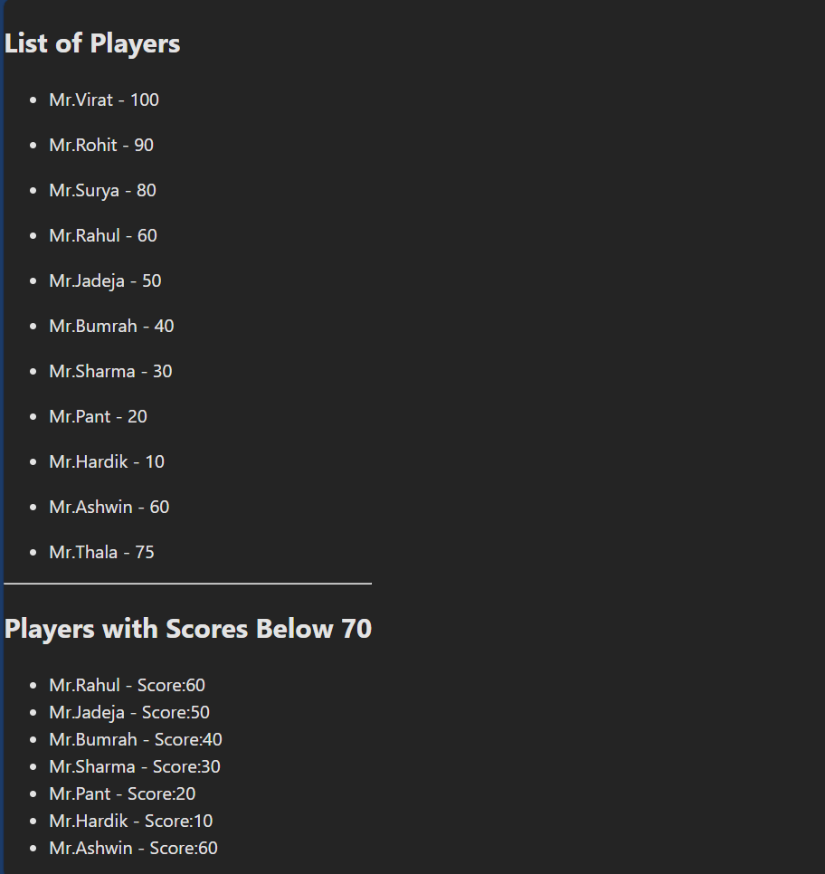

While flag == false;

